**Dạng 1: INFERENCE ON THE DIFFERENCE IN TWO POPULATION MEANS OF TWO NORMAL DISTRIBUTIONS, VARIANCES KNOWN 🡪 Z Test**

| **Step** |  | **Two-tailed Test** | **Right-tailed Test** | **Left-tailed Test** |
| --- | --- | --- | --- | --- |
| **1** | **Formulate the 2 hypotheses** |  |  |  |
| **2** | **Compute**  **test statistic** |  | | |
| **3** | **Identify**  **critical values** |  |  |  |
| **4** | **Decision** | If the test statistic is in region of rejection 🡪 **Reject**  If the test statistic is in region of non-rejection 🡪 **Fail to Reject** | | |

E.g., A product developer is interested in reducing the drying time of a primer paint. Two formulations of the paint are tested; formulation 1 is the standard chemistry, and formulation 2 has a new drying ingredient that should reduce the drying time. From experience, it is known that the standard deviation of drying time is 8 minutes, and this inherent variability should be unaffected by the addition of the new ingredient. Ten specimens are painted with formulation 1, and another 10 specimens are painted with formulation 2; the 20 specimens are painted in random order. The two-sample average drying times are minutes and minutes, respectively. What conclusions can the product developer draw about the effectiveness of the new ingredient, using 0.05?

**Parameter of interest:** The quantity of interest is the difference in mean drying times between the standard chemistry and new drying ingredient.

**Dạng 2: INFERENCE ON THE DIFFERENCE IN TWO POPULATION MEANS OF TWO NORMAL DISTRIBUTIONS, VARIANCES UNKNOWN AND ASSUME EQUAL VARIANCE 🡪 Pooled-Variance t Test**

| **Step** |  | **Two-tailed Test** | **Right-tailed Test** | **Left-tailed Test** |
| --- | --- | --- | --- | --- |
| **1** | **Formulate the 2 hypotheses** |  |  |  |
| **2** | **Compute**  **test statistic** | (pooled variance) | | |
| **3** | **Identify**  **critical values** |  |  |  |
| **4** | **Decision** | If the test statistic is in region of rejection 🡪 **Reject**  If the test statistic is in region of non-rejection 🡪 **Fail to Reject** | | |

E.g., Two catalysts are being analyzed to determine how they affect the mean yield of a chemical process. Specifically, catalyst 1 is currently in use, but catalyst 2 is acceptable. Since catalyst 2 is cheaper, it should be adopted, providing it does not change the process yield. A test is run in the pilot plant and results in the data shown in Table 10-1. Is there any difference between the mean yields? Use alpha = 0.05 and assume equal variances.

Answer:

**Parameter of interest**: The quantity of interest is the difference in mean process

yield between catalysts 1 and 2.

**Dạng 3: INFERENCE ON THE DIFFERENCE IN TWO POPULATION MEANS OF TWO NORMAL DISTRIBUTIONS, VARIANCES UNKNOWN AND NOT ASSUME EQUAL VARIANCE 🡪 Separate-variance t test**

**Compute test statistic**

E.g., Arsenic concentration in public drinking water supplies is a potential health risk. An article in the Arizona Republic (May 27, 2001) reported drinking water arsenic concentrations in parts per billion (ppb) for 10 metropolitan Phoenix communities and 10 communities in rural Arizona. The data follow:

We wish to determine if there is any difference in mean arsenic concentrations between metropolitan Phoenix communities and communities in rural Arizona. Figure 10-3 shows a normal probability plot for the two samples of arsenic concentration. The assumption of normality appears quite reasonable, but since the slopes of the two straight lines are very different, it is unlikely that the population variances are the same.

Answer:

**Parameter of interest:** The quantity of interest is the difference in mean arsenic concentrations between Metro Phoenix and Rural Arizona.

**Dạng 4: INFERENCE ON DIFFERENCE IN TWO POPULATION PROPORTIONS 🡪 Z Test for the Difference Between Two Proportions**

| **Step** |  | **Two-tailed Test** | **Right-tailed Test** | **Left-tailed Test** |
| --- | --- | --- | --- | --- |
| **1** | **Formulate the 2 hypotheses** |  |  |  |
| **2** | **Compute**  **test statistic** | (pooled proportion) | | |
| **3** | **Identify**  **critical values** |  |  |  |
| **4** | **Decision** | If the test statistic is in region of rejection 🡪 **Reject**  If the test statistic is in region of non-rejection 🡪 **Fail to Reject** | | |

E.g., Extracts of St. John’s Wort are widely used to treat depression. An article in the April 18, 2001, issue of the Journal of the American Medical Association (“Effectiveness of St. John’s Wort on Major Depression: A Randomized Controlled Trial”) compared the efficacy of a standard extract of St. John’s Wort with a placebo in 200 outpatients diagnosed with major depression. Patients were randomly assigned to two groups (each group has 100 patients); one group received the St. John’s Wort, and the other received the placebo. After eight weeks, 19 of the placebo-treated patients showed improvement, whereas 27 of those treated with St. John’s Wort improved. Is there any reason to believe that St. John’s Wort is effective in treating major depression? Use alpha = 0.05.

Answer:

**Parameter of interest:** The quantity of interest is the difference in proportion of patients who improve following

treatment with St. John’s Wort or the placebo.

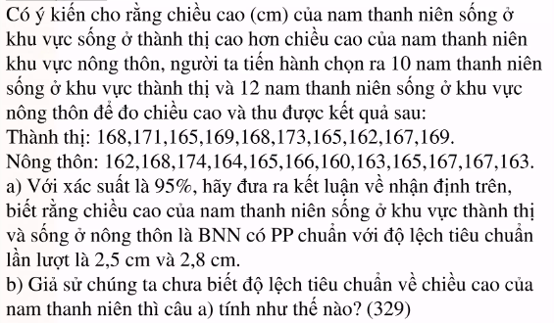

**b) assumed equal variance**

